Cultural Competency
Name: Date:__________________

- Lack of awareness about cultural differences makes it easier for both providers and consumers to achieve the best, most appropriate service.
True False

- Cultural competence is a set of behaviors, attitudes, and policies that come together in an organization to enable it to work effectively in cross-cultural situations.
True False

- Each person is a member of only one culture.
True False

- Check the following that are examples of different cultures:
_______ Family ______ Neighborhood
_______ Spiritual ______ Ethnic
_______ Work _______ Gender
_______ Age _______ Common Interest
- The term culture is analogous to community, but culture relates more to the behaviors manifested by the community. True False

- Race is a ___________ and ____________ construct that is most often important in societies with a history of oppressing specific groups.

- Ethnicity is a classification of humans according to physical characteristics.
True False

- Cultural __________________ is when differences are seen as a problem; identifies one superior culture. Cultural ____________ is when one feels all cultures are alike; culture does not account for differences. Cultural _________________ is when one recognizes differences but is complacent in making change.

- The five essential elements that contribute to an organization’s ability to become more culturally competent
The organization should:
(1) ____________ diversity,
(2) have the capacity for cultural _________________,
(3) be conscious of the _______________ inherent when cultures interact,
(4) ___________________ _______ of cultural knowledge,
(5) developing adaptations to service delivery reflecting and __________________ of diversity between and within cultures.
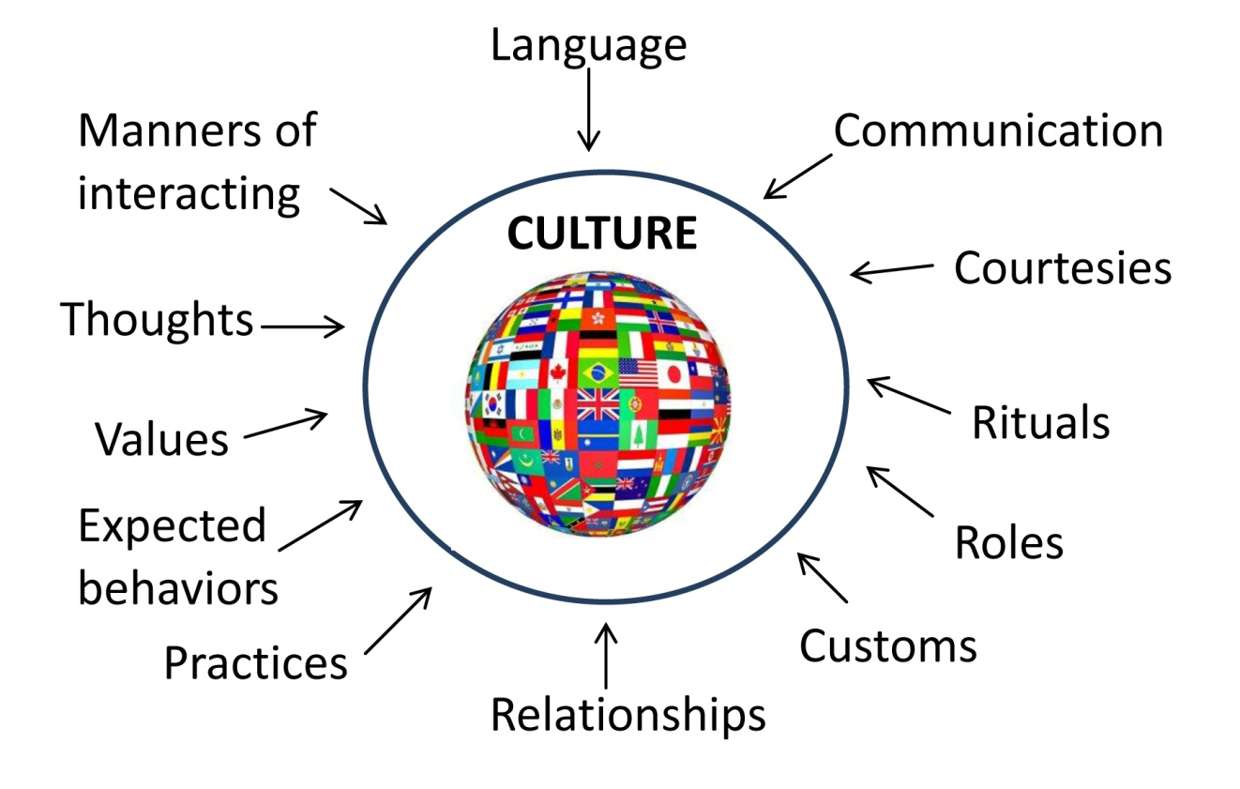

“If we are to achieve a richer culture…we must weave one in which each diverse human gift will find a fitting place.” Margaret Mead 1935

