Safety Manual and Emergency Plans

For
Chatham Trades, Inc.

March 2020

Safety Manual and Emergency Plan Record of Changes

Description of Changes | Date | Review/Revision by
Review | 2018 | Shawn Poe
Revision | 7/1/2019 | Shawn Poe
Revision | 3/18/2020 | Jessica Godfrey

I. POLICY STATEMENT

It is the policy of Chatham Trades to provide a safe work environment, free of all occupational and safety hazards. Ultimate responsibility for safety and emergency plans is vested with the Executive Director. It is the responsibility of the Board of Directors to establish and monitor the Safety Program. The Executive Director makes an annual report to the Board of Directors.

II. SAFETY COMMITTEE

- The Safety Committee is responsible for insuring a safe work environment for all employees. The Committee Chair should insure that all departments operate in a hazard-free manner and bring to the attention of the Executive Director any situations that present an occupational hazard to the health or safety of Chatham Trades’ employees.

- The Chair of the Safety Committee is appointed by the Executive Director. That person is responsible for holding regular meetings of the Safety Committee, assuring that the safety program is implemented and planning/conducting all safety drills.

- The Safety Committee shall meet on a monthly basis for the purpose of reviewing the safety checklist, accident reports, and overall safety of the facility.

- The Safety Committee shall be composed of both staff and consumers. Minutes of the meetings and recommendations resulting from the meetings of the Safety Committee shall be submitted in writing to the Executive Director.

III. STAFF AND CONSUMER TRAINING

- Each staff member and consumer will receive safety orientation and training.

- Training will include first aid instruction, accident prevention, prevention of disease transmission, and emergency procedures.

- The Assistant Director and/or Safety Committee Chair will ensure that each new staff and consumer has received adequate training in safety.

IV. FIRST AID PROGRAM

- Chatham Trades will ensure that there will be available at least one staff member qualified to administer First Aid during all working hours. All direct care staff will be trained/certified in CPR and First Aid. Staff is not required to provide first aid as a part of their job.
- First Aid kits are available in the receptionist’s office, med room, break room, production manager’s office and on the main work floor. Each staff member also has a mini first aid bag at their desk. Additionally, the delivery truck is equipped with a first aid kit.

- In the event of an injury, seizure, or other bodily emergency, the employee’s supervisor will be notified immediately, and the first aid personnel should be called to the sight of the injury. A list of qualified Chatham Trades staff trained in first aid will be posted in the receptionist’s office, med room, break room, production manager’s office and on the main work floor.

- If the injury is minor, the first aid person may administer first aid and allow the employee to return to work.
- If the injury appears to be more serious, the first aid person and one additional staff person will take the employee to UNC Primary Care at Chatham. A call is to be made by office personnel to inform them that someone is being brought in for treatment.
- If conditions are too serious to be treated at the doctor’s office, call the Rescue Squad at 911.
- Fill out an Incident/Accident report.
- Fill out OSHA report, if treatment other than one-time first aid is required.
- If an accident results in loss of days away from work, a Worker’s Compensation Report should be filed by the Supervisor.
- A copy of the accident report/incident should go the following people:
  - Executive Director
  - Assistant Director

V. EMERGENCY PLANS

- FIRE (Audible Central Fire Alarm)

- In the event of a fire in the building, the staff discovering the fire shall activate the fire alarm and then immediately call the Executive Director to report the exact location of and the type of fire. If the Executive Director is not available, contact the Assistant Director.
- The alarm system should be activated by the pull station. The alarm monitoring company calls the Fire Department.
- Upon hearing the fire alarm, consumers and staff should evacuate the building according to the evacuation plan outlined in the next section.
- Fire drills are held at least quarterly, at random times with random exits blocked.
- All staff is trained annually on the proper use of fire extinguishers. Staff is not required to use a fire extinguisher as a part of their job.
- A report of the effectiveness and/or any problems encountered should be made by the Safety Chair to the Safety Committee and the Executive Director in writing.
- GENERAL EVACUATION PLANS

- In the event it becomes necessary to evacuate the building, staff will ensure that consumers leave the building via the nearest available exit, as indicated on the posted evacuation plan.
- Staff should close office doors. It is not necessary to turn off lights.
- Staff should cut off power to machinery.
- After exiting the building, everyone will assemble at the cement pad outside which is the designated headcount meeting area.
- A staff member and a backup person will be assigned to individuals needing special assistance, particularly those who are physically, visually or hearing impaired, to ensure that they exit the building safely and rapidly. All available staff trained in CPR/First Aid may assist with injuries/illnesses.
- A headcount using the roll will be taken by the Safety Chair or the Assistant Director to ensure that all consumers, staff, and visitors have exited the building.
- The Executive Director or staff in charge will be responsible for making any phone calls to the alarm company.
- No one will re-enter the building without notice from the Executive Director or staff member in charge.
- In the event that the cement pad is too close to the situation, staff will relocate everyone to the parking lot in front of the building.
**A wheelchair is located in the med room if needed**

- POWER FAILURE

- In the event of a power failure all personnel should remain at their work stations and await instructions. Each Unit Supervisor, Hab Tech, and office staff has a flashlight in their desk to use.
- Weather permitting, Unit Supervisors may open the exit doors and prop them open to allow maximum light and air into the building.
- Everyone should remain quiet at their work stations until instructions are provided by a staff member.
- There are emergency lights in all areas of the building that operate during a power failure.
- Restrooms in the front office area and the lobby have tap lights for emergency lighting.

- SEVERE WEATHER OR TORNADO (Whistle/Intercom announcement)

- In the event of a severe weather or tornado watch, all employees will be advised that a severe weather or tornado watch is in effect.
- If the weather situation becomes more serious employees will be advised to assemble in the breakroom, front office restroom, lobby restroom and any other location designated by a yellow tornado-safe placard.
- The Safety Chair will conduct a headcount using the roll of the employees and visitors to ensure everyone is present and accounted for. In the Chair’s absence, the Assistant Director will take roll.

- BOMB THREAT

- A bomb threat may be received by various means, but will usually be by telephone.
- The recipient of the call should immediately notify the office.
- The Executive Director or designee shall immediately notify the police: Emergency Services 911.
- The Executive Director or designee will announce over the intercom: ATTENTION. PLEASE STOP WHAT YOU ARE DOING AND EVACUATE THE BUILDING IMMEDIATELY. Staff will recognize this as a bomb threat.
- Everyone will evacuate the building immediately in accordance with the evacuation plans posted in each room or work area.
- Look closely at doors before opening them to go out. If there is anything suspicious on or near the door, use another exit to evacuate the building.
- Leave as many doors open as possible.
- Do not touch or move anything in the building.
- Do not turn any electrical switches on or off.
- Do not search the building.
- Do not attempt to remove any suspicious objects or packages.
- The staff will make sure all occupants evacuate to the headcount meeting area or the front parking lot.
- Roll will be taken by the Safety Chair or Assistant Director to ensure that everyone evacuated the building.
- Employees will not return to the building until it has been declared safe by the authorities.

VI. EMERGENCY PROCEDURES FOR DELIVERY DRIVER

A. ACCIDENT

  - Call 911 for police or rescue.
  - Call Chatham Trades (919-663-3481) to inform them of the situation.
  - Insurance and registration card should be in the glove compartment of the truck at all times.
  - If after hours, call the following people in order:
    - Shawn Poe, Director, 919-837-5114/919-545-1018
    - Elaine Dixon, Office Manager, 919-742-4645/919-548-3474
  - Stay with the vehicle until towed if unable to drive.

VII. MAJOR DISASTER GUIDELINES

If possible, we will remain at Chatham Trades and notify everyone to pick employees up at this site. If we decide to evacuate, then it will be the responsibility of the caregiver to pick up consumers at the shelter or make arrangements with the shelter.

The chain of command for evacuation is as follows:

- Shawn Poe, cell phone 919-545-1018
- Jillian Stone, cell phone 984-265-0400
- Jessica Godfrey, cell phone 919-353-9953
- Elaine Dixon, cell phone 919-548-3474

If evacuation to a shelter is necessary, we will move to:

JORDAN MATTHEWS HIGH SCHOOL (Map attached)
910 E CARDINAL STREET
SILER CITY, NC
919-742-2916

The following transportation options are available during an evacuation:

- Call Chatham Transit Network first. 919-542-5136.
- If Chatham Transit is unable to transport our consumers, then authorized Chatham Trades staff will transport using personal vehicles or production vehicle.
- Call the Chatham County Sheriff’s Department and Emergency Operations Center to assist with transporting consumers to a shelter. The telephone number for both is 919-542-2811.

The following items need to be taken as a precautionary measure:

- Disaster Kit – Red/black rolling duffle bag located in the med room shower. Includes such things as batteries, radio, flashlights, blankets, bottled water, and first aid kit with other supplies, disinfectant wipes, scissors, and latex gloves. The Safety Chair or the Executive Director is responsible for securing the Disaster Kit for transport.
- Consumer and staff emergency information. The Assistant Director will transport the file.
- Consumer medication – Staff in charge of administering medication will transport the medicine in the lockable med bag.
- Emergency Procedures Notebook – This includes roll of all staff and consumers, emergency management numbers, and other necessary information pertaining to Chatham Trades. Office personnel will take this with them to shelter.
- Computer back-up files – Office personnel will be responsible for taking these records with them to shelter.

VIII. LIST OF RESPONSIBILITIES FOR EMERGENCY EVACUATION

- EXECUTIVE DIRECTOR
  - Vocational Services Assistant’s office
  - Assistant Director’s office
  - Salvation Army Offices
  - Food Pantry
PROCEED TO WORK FLOOR TO ASSIST
*Administrative Assistant will serve as back-up

- ASSISTANT DIRECTOR
  - Executive Director’s office
  - Quality Assurance Manager’s Office
  - Copy Room
  - Office Manager’s Office
  - Reception Office
  - Hallway Bathroom
  - Take the Emergency contact numbers for staff/consumers
PROCEED TO WORK FLOOR TO ASSIST
*Administrative Assistant will serve as back-up

- VOCATIONAL SERVICES ASSISTANT
  - Conference Room
  - Relaxation Room
  - Staff Workroom
  - Production Manager’s Office
  - Med Room
PROCEED TO WORK FLOOR TO ASSIST
*Administrative Assistant will serve as back-up

- ADMINISTRATIVE ASSISTANT
  - Take the Emergency plan book, back up files and the roll.
  - Lobby
  - Lobby Bathroom
PROCEED TO WORK FLOOR TO ASSIST
*Office Manager will serve as back-up

- UNIT SUPERVISORS
  - Work floor bathrooms
  - File storage room
  - Break room
  - Outside break area

Each Unit Supervisor will be responsible for getting their consumers out of the building. Hab. Techs/CNAs will be responsible for getting their consumers out. If needed, they will ask other staff to assist. All staff should be aware of anyone needing assistance with getting everyone out safely.

IX. STEPS TO OBTAIN MEDICAL ASSISTANCE

- Notify supervisor/first aid responder to assess the situation. A list of persons certified in First Aid/CPR is posted next to first aid kits located in the receptionist’s office, break room, med room, production manager’s office and on the main work floor. If the accident/illness is too serious to transport, call 911. The 911 address for Chatham Trades is 2535 Old US Highway 421 North, Siler City, 27344; located beside International Precast/International Vault.

- If the individual can be transported, the following procedures apply:

Contact UNC Primary Care at Chatham at 919-742-3062 to notify them that you are on your way and the condition of the individual.

Directions to UNC Primary Care at Chatham (map attached) :(163 Medical Park Dr. Suite 220) Turn right out of the parking lot. Bear left at the fork in the road to the stop light. Turn left on Highway 64 West. Go through five (5) stoplights; pass Walmart and Murphy Gas on right. Turn right on Progress Boulevard. Go 1 mile. Turn left at the hospital after the helicopter pad (Medical Park Dr.) The building will be on the right. Enter in the middle of the building and take the elevator to the second floor.

- If the individual is transported by Emergency Services, the supervisor of that consumer will go to the hospital.

Directions to the hospital (map attached): (475 Progress Blvd) Take a right out of Chatham Trades parking lot. Bear left at the fork in the road to the stop light. Turn left onto Highway 64 West. Go through five (5) stoplights. Pass Walmart and Murphy Gas on your right. Turn right on Progress Boulevard. Chatham Hospital is approximately 1 mile on the left.

  - Bring the individual’s emergency information from the Assistant Director’s office. The information should have the following on each person. Give the card to the hospital and bring it back when done.
    - Name/address
    - Emergency contact person
    - Date of birth
    - Telephone number
    - Social Security number
    - Medications
    - Allergies
    - Insurance/Medicaid #

- Accident/Incident reports should be filled out and turned into the Vocational Services Manager. A copy should go to the Executive Director.

- The Executive Director or Assistant Director will call the individual’s family/caregiver/guardian to notify them of the accident/illness and the action taken.

- The Office Manager will be responsible for completing the necessary forms and submitting them to the appropriate insurance carrier.

Directions to Jordan-Matthews High School (Emergency Shelter)
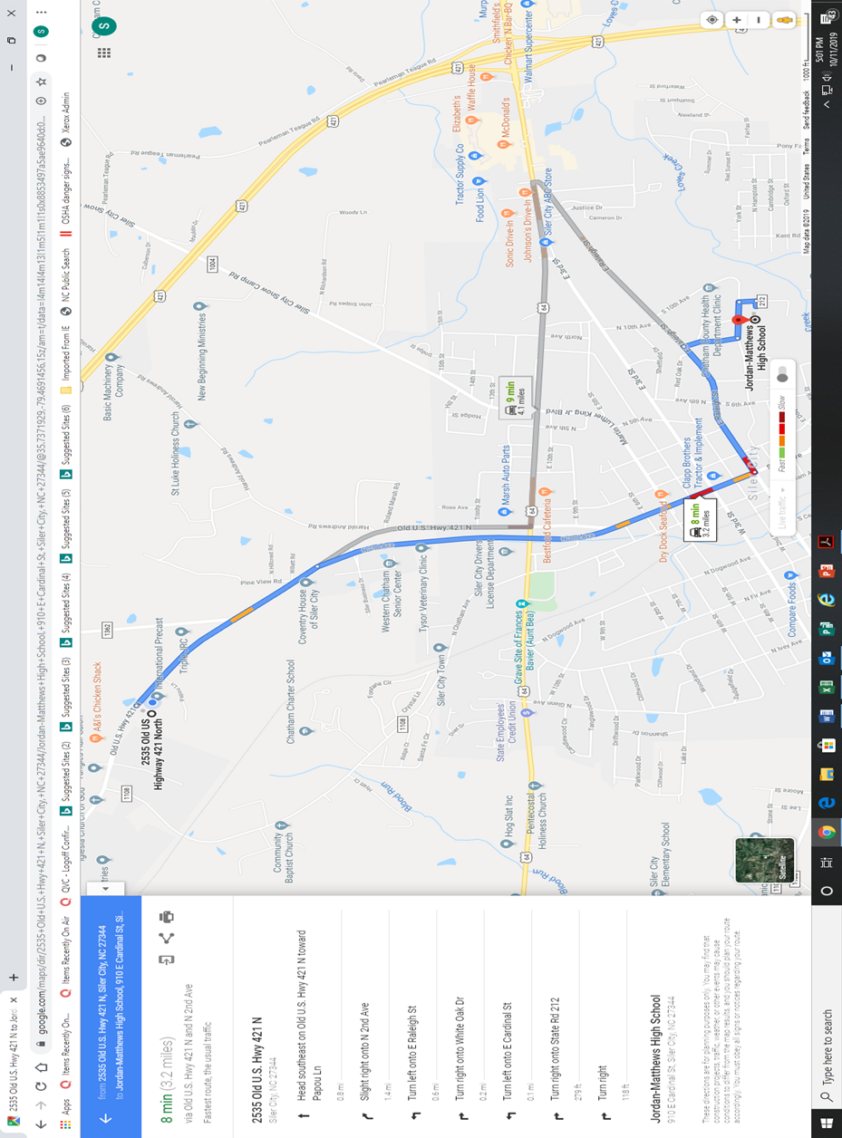

Directions to UNC Primary Care of Chatham
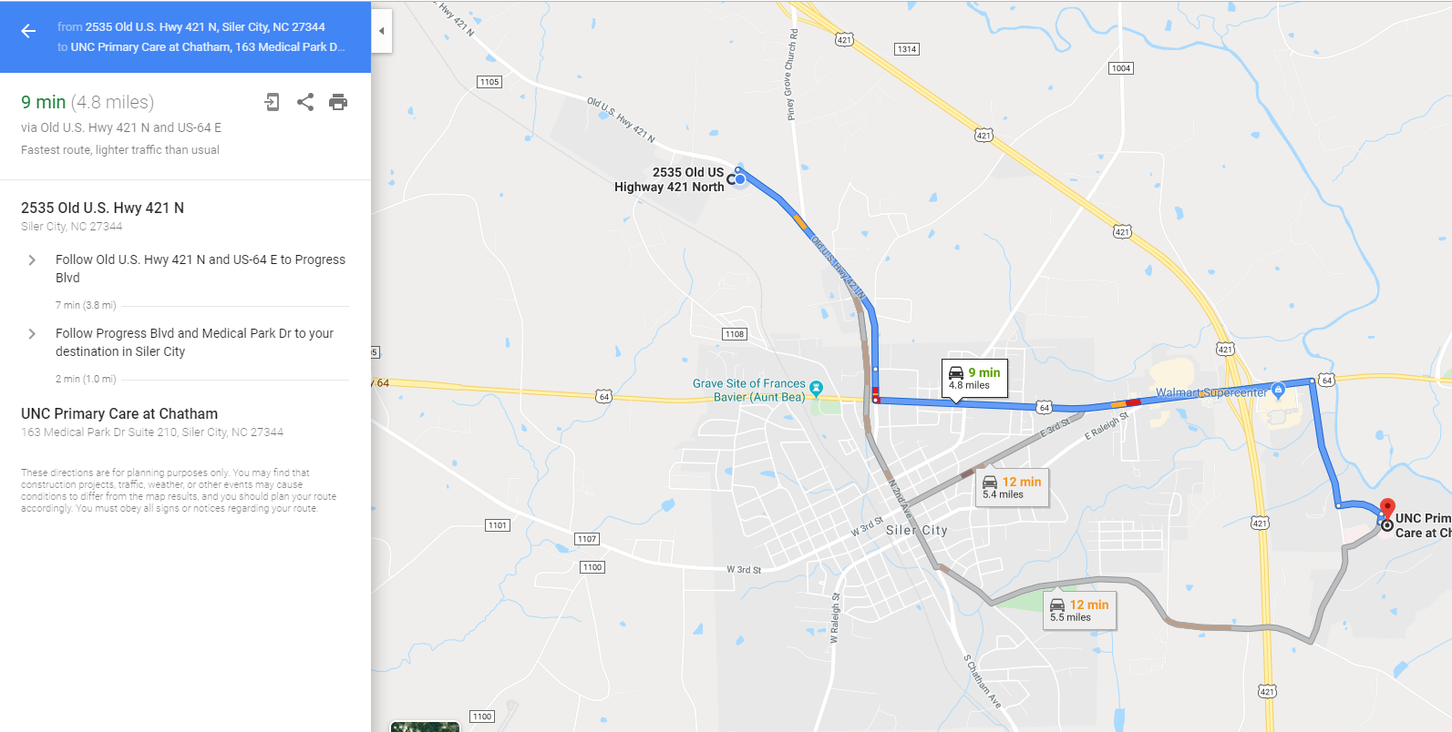
Directions to Chatham Hospital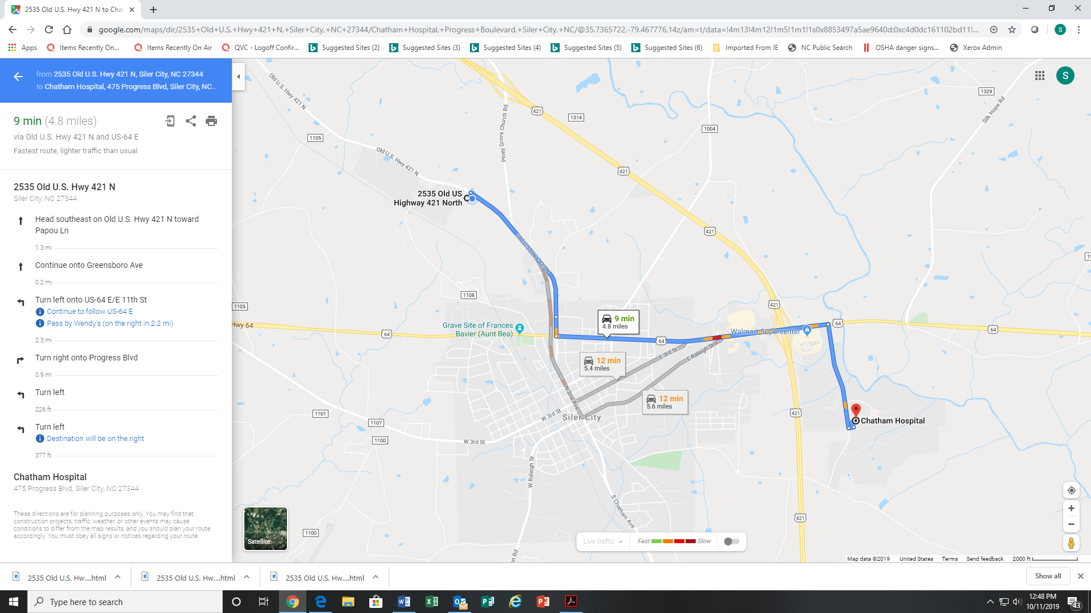

Emergency Numbers

FIRE: 911

AMBULANCE: 911

POLICE: 919-742-5626

CHATHAM HOSPITAL: 919-799-4000

UNC PRIMARY CARE AT CHATHAM: 919-742-6032

CHATHAM COUNTY EMERGENCY OPERATIONS: 919-542-2811, ext. 6

CHATHAM COUNTY SHERIFF’S DEPARTMENT: 919-542-2811

NON-URGENT EMERGENCIES: 919-542-2911

CHATHAM TRADES, INC.

CHAIN OF COMMAND FOR EMERGENCIES

- Shawn Poe, Executive Director (cell # 919-545-1018)

- Jillian Stone, Assistant Director (cell # 984-265-0400)

- Jessica Godfrey, Safety Committee Chair (cell # 919-353-9953)

- Elaine Dixon, Office Manager (cell # 919-548-3474)

